**Schema Design:**

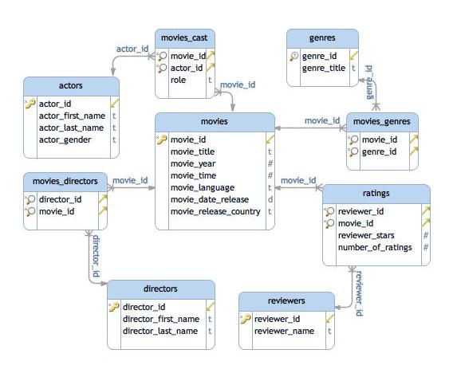

**Write a SQL Query to find the name of those movies where one or more actors acted in two or more movies.**

SELECT movie_title

FROM movies

JOIN movies_cast

ON movies_cast.movie_id=movies.movie_id

JOIN actors

ON movies_cast.actor_id=actors.actor_id

WHERE actors.actor_id IN (

SELECT actor_id

FROM movies_cast

GROUP BY actor_id HAVING COUNT(*)>=2);